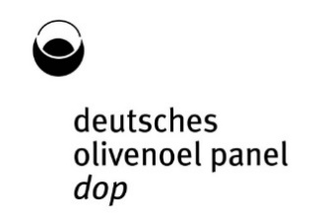
DOP Profile Sheet

Intensity of PERCEPTION OF DEFECTS

fusty
(stichig)

muddy sediment
(schlammig)

musty, humid, earthy *
(modrig, feucht, erdig)

winey, vinegary, acid-sour *
weinig, essigartig, säuerlich
* Zutreffendes unterstreichen
frostbitten olives (wet wood)
erfrorene Oliven (nasses Holz)
rancid
ranzig

others attributes
specify with alternatives

grubbylic
metallic
hay/wood
roughlic

vegetable water
heated/burnt
brinee

espartoe
cucumberre
greasye

PERCEPTION OF POSITIVE ATTRIBUTES

fruity
fruchtig

green/grün ripe/reif

bitter
bitter

pungent
scharf
.
Harmonie
balance

SAMPLE Temperature in limit 28°C ± 2°C: yes no
Serie | Sample Code | Taster code / Name/ID  G | Date | Signature

